*Moonrise Kingdom* (2012)

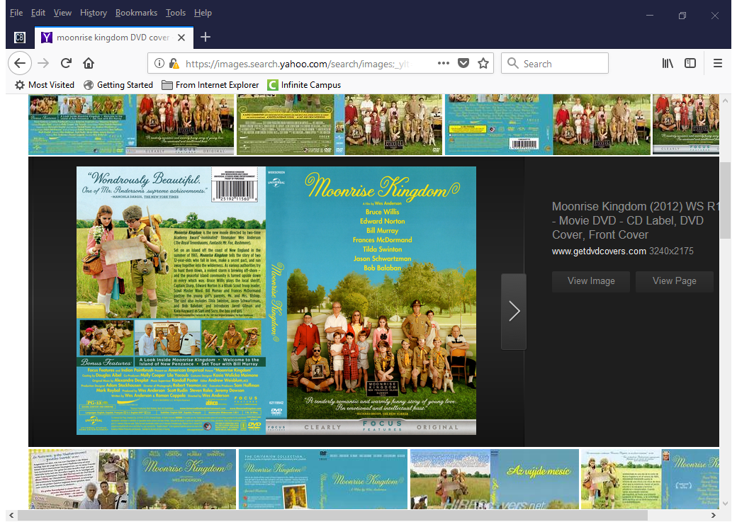

DIRECTOR: Wes Anderson

CAST:

* Bruce Willis—Captain Sharp
* Edward Norton—Scout Master Ward
* Frances McDormand—Mrs. Bishop
* Bill Murray—Mr. Bishop
* Tilda Swinton—Social Services
* Jared Gilman--Sam
* Kara Hayward—Suzy Bishop
* Jason Schwartzman—Cousin Ben
* Bob Balaban—The Narrator

MUSIC BY: Alexandre Desplat

Oscar Nomination for Best Writing, Original Screenplay: Wes Anderson and Roman Coppola

*Moonrise Kingdom* (2012)



DIRECTOR: Wes Anderson

CAST:

* Bruce Willis—Captain Sharp
* Edward Norton—Scout Master Ward
* Frances McDormand—Mrs. Bishop
* Bill Murray—Mr. Bishop
* Tilda Swinton—Social Services
* Jared Gilman--Sam
* Kara Hayward—Suzy Bishop
* Jason Schwartzman—Cousin Ben
* Bob Balaban—The Narrator

MUSIC BY: Alexandre Desplat

Oscar Nomination for Best Writing, Original Screenplay: Wes Anderson and Roman Coppola